Figure-1.2.1 Complete transistor-level schematic of the CMOS inverter
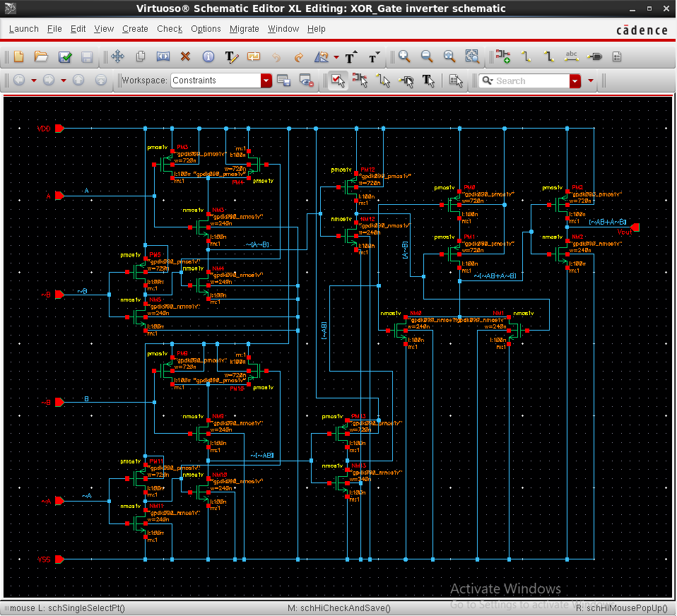

Figure-1.2.2 Complete transistor-level schematic of the CMOS inverter
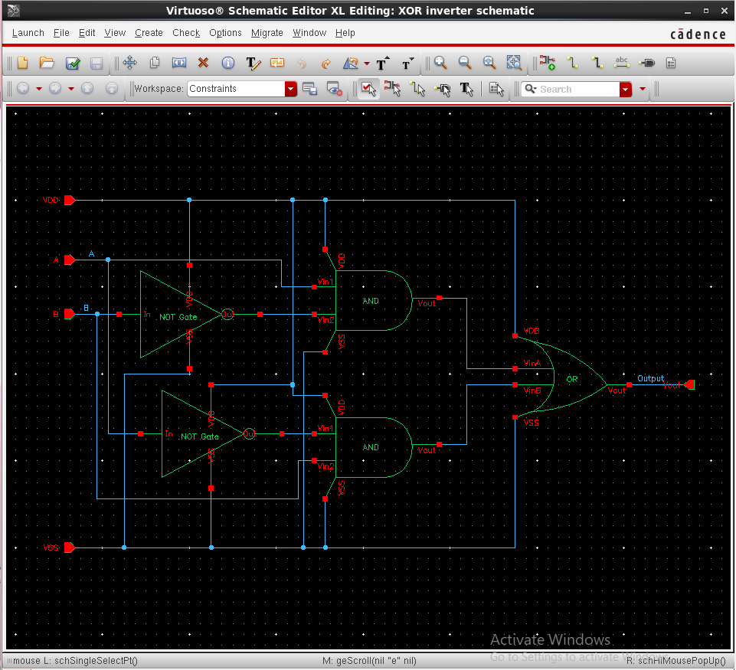

Figure-1.3. Generated schematic symbol of the CMOS OR inverter
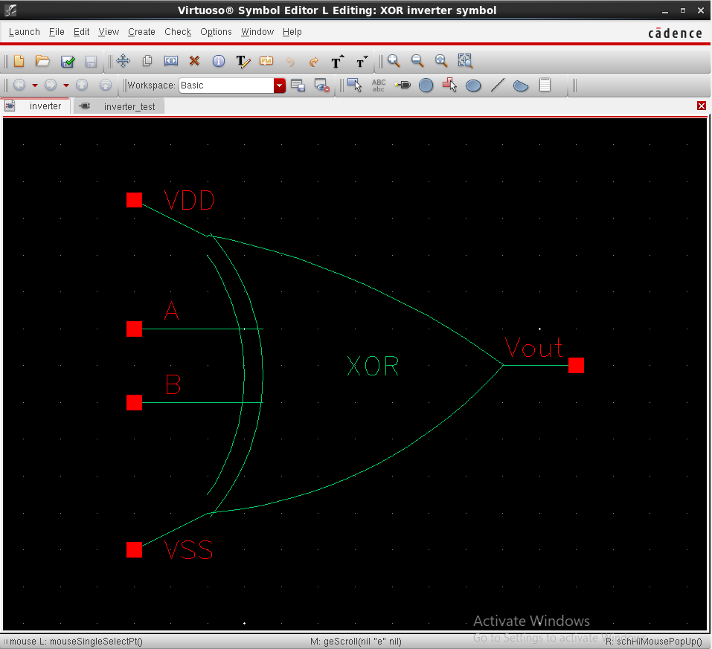

Figure-1.4.4 Test bench schematic (OR inverter_test)
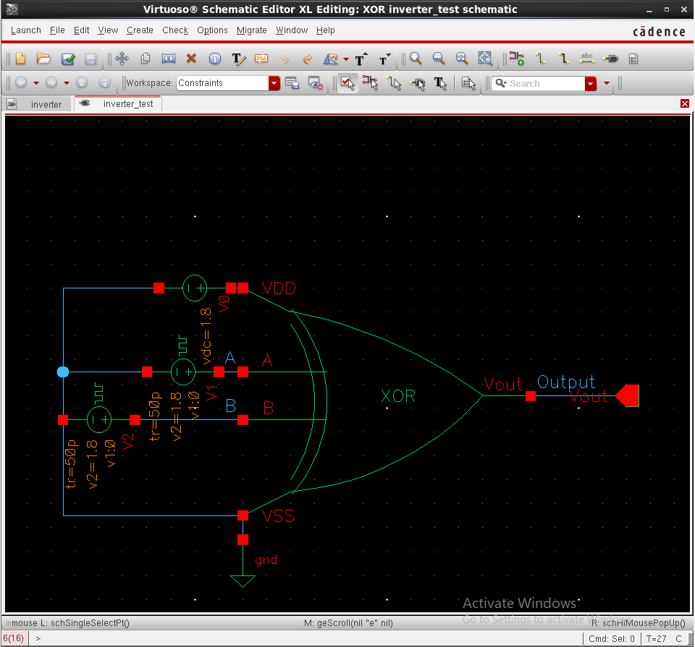

Figure-1.5. OR Simulation results
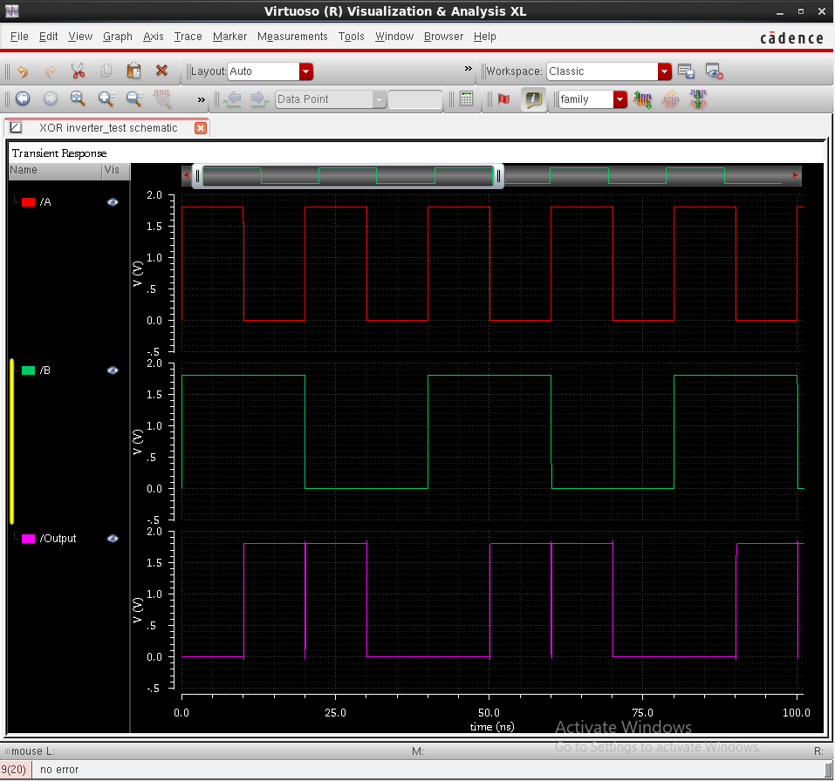

Figure-1.4.1. Add Instance window showing vpulse1 (OR Input A)
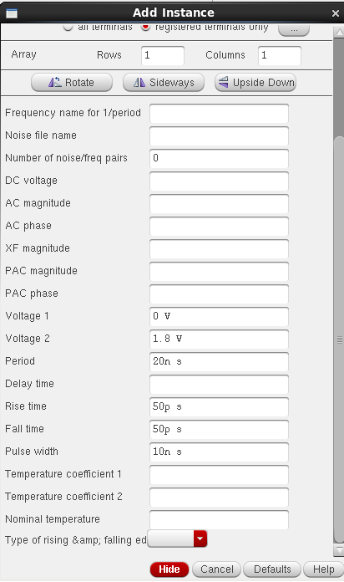

Figure-1.4.2. Add Instance window showing vpulse2 (OR Input B)
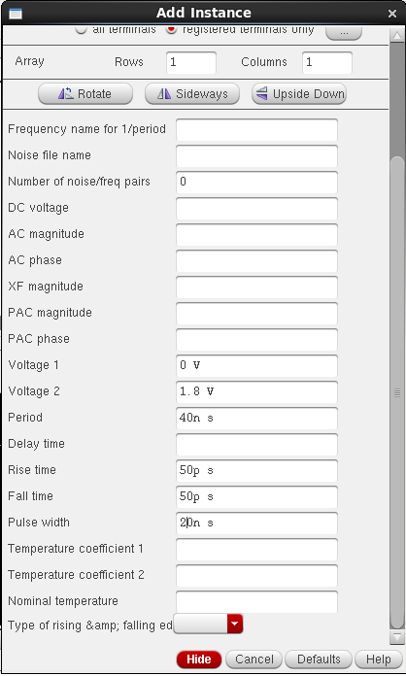

Figure-1.4.3. Add Instance window showing vdc (OR inverter_test VDD)
